How Computer Memory Works
Student’s Name
Institution
Course
Professor’s Name
Date

How Computer Memory Works
Computer memory plays different roles, with the main purpose being storing the information for future reference. Whether the information intended to be stored is very short like a one or two-word text or a large text, computer stores information in basic units called bits or binary digits.
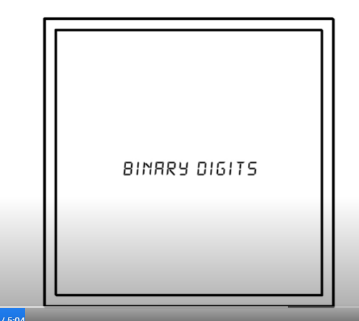 Binary Digits
Each of the information in form of binary digits is stored in memory cells as shown above. The information is stored in two possible values, ones and zeros (1 or 0). Different files, depending on the size, are stored in millions of these housing or cell units in the computer memory which are all processed in the computer’s central processing unit (CPU).
Computer memory is very much like the human memory, in the sense that it has both long-term and short-term memory storage units. Like the way human short-term memory is responsible for the immediate tasks, the computer’s memory also processes information that may be needed for immediate tasks while it stores the permanent solutions or instructions in the long-term memory.
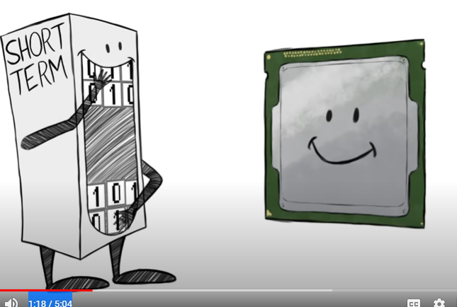 Short-term memory
Short-term memory is used when the computer is required to open an application. Therefore, a computer user opens an application on the computer; the computer allocates the instruction on the short-term memory area to facilitate the performance of the immediate task, which is to open the application. To facilitate easy and smooth access of the information by a single button, the computer’s Random Access Memory (RAM) which makes it easy for the computer to access all the information from all locations.
However, the storage of such information only occurs as long as the power stays on. Information stored in the long-term memory involves data that has been transferred from the short-term memory to enable them be stored when the power goes off. In the long-term memory, the computer stores data in two ways; magnetic patterns and optical-based storage.
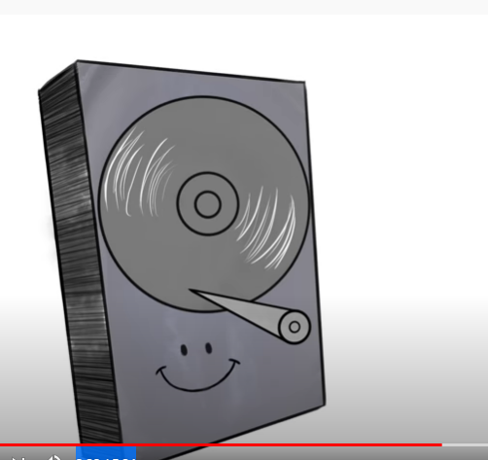 Spinning disks (Magnetic storage)
The magnetic pattern storage is almost a thousand times slower than the optical-based storage such as DVDs. The difference is that in optical-based storage, data is stored in light and dark spots, which makes it easy to be read by a laser. Magnetic storage are cheaper but they have the lowest lenience (time to process data) compared to the optical-based storage.
As the technology increases, computer designers are coming up with more advanced storage units to support the computer long-term memory capacity. This includes the solid state drives with no moving parts like the previous types. They are much faster than both magnetic and optical-based storage.
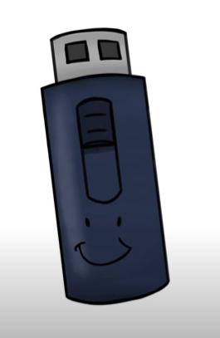 Solid state drive

Reference
Senanan, K. (2016, May 10). How Computer Memory Works. TED-Ed (YouTube). Retrieved from https://www.youtube.com/watch?v=p3q5zWCw8J4&t=5s

